SNHU • CS 210 • Project Three

Corner Grocer
Item Tracking Program

Technical Design Document

Project Overview

Author | Jeremy R. Pauley
Course | CS 210 : Programming Languages
Institution | Southern New Hampshire University
Project | Project Three : Corner Grocer Tracking Program
IDE / Environment | Visual Studio Code
Date | April 15th, 2026

This document provides a full technical breakdown of the Corner Grocer Item Tracking Program, including design decisions, architecture, and implementation details. Screenshots are included throughout to demonstrate functionality and support each feature.
While the assignment specifies a one-page summary, explicit permission was requested from and granted by the course instructor to expand beyond this requirement. This extended version is intended to fully document the development process, demonstrate deeper technical understanding, and support inclusion in a professional portfolio.

Jeremy R. Pauley • CS 210 • Southern New Hampshire University
Modular Design • Doxygen Annotation • Input Validation • C++ Best Practices

Assignment Clarification & Design Interpretation

Understanding the Problem
The Corner Grocer is a small retail store that generates a chronological text log of every item purchased throughout a single business day. By the time the store closes, this file contains potentially hundreds of item names listed one per line. Without any analysis tool, store managers must manually review this raw text to understand which products were popular and which were not, a slow and error-prone process.
The store's core need is an automated program that reads this file, counts how many times each product appears, and presents that frequency data to the user in multiple useful formats. The ability to identify high demand items is directly linked to better store layout decisions. If strawberries are purchased far more often than radishes, placing strawberries near the entrance and pairing them with complementary products becomes a data driven decision rather than a guess.
This project meets business needs with a complete C++ application: four menu-driven features, optional enhancements including input validation and fuzzy search suggestion, and a fully annotated modular codebase.

Core Functional Requirements
Four behaviors are required by the rubric:

Menu Option | Required Behavior | Output Format
Option 1 | User enters one item name; program returns its purchase frequency as a numeric value. | Single integer count
Option 2 | Program prints every item paired with its numeric frequency count. | Line-by-line list
Option 3 | Program prints every item followed by asterisks equal to its frequency count. | Text-based histogram
Option 4 | Program exits cleanly. | Closing message

On top of the four menu options, the rubric requires automatic creation of frequency.dat, a backup of all item counts, written before the menu loop starts, without any user prompt. That file is the program's only persistent output.
The rubric also requires at least one class with public and private sections, industry standard best practices including in line comments and consistent naming conventions, and clear, readable code throughout.

Design Interpretation & Approach
The assignment description intentionally leaves certain design decisions open. Where to store data, how to structure the class, how to separate menu logic from data logic, and whether to add enhancements are all judgment calls the developer must make.
This solution interprets the assignment not as the minimum required submission, but as an opportunity to demonstrate production quality thinking within a beginner to intermediate C++ context. The key design decisions made in this implementation are:

- Use std::map as the primary data container because it provides built in key based lookup and sorted iteration with no additional implementation cost.

- Separate each menu option into its own source file and header so that the codebase is modular, easy to navigate, and easy to grade independently.

- Placement of the GroceryTracker class in a dedicated folder that is physically separate from the menu implementation to enforce the boundary between data management and display logic.

- Add input validation, empty-input protection, and closest match suggestions as portfolio level enhancements that go beyond the rubric without violating any requirement.

- Apply a documented Doxygen-style annotation standard consistently across all source and header files, with a written guideline document to explain the approach.

Solution Planning & Pseudocode

High-Level Program Flow
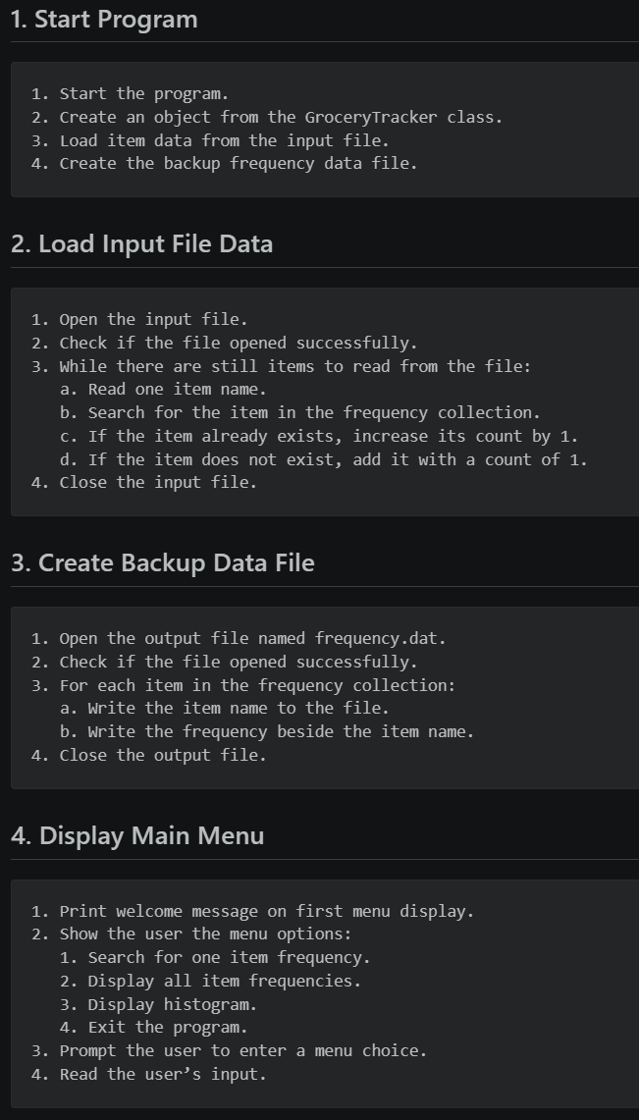
The pseudocode was written before any C++, a top to bottom walkthrough of what the program needed to do, committed to the repository as Project_3_Pseudocode.md. Every implementation decision referenced it.

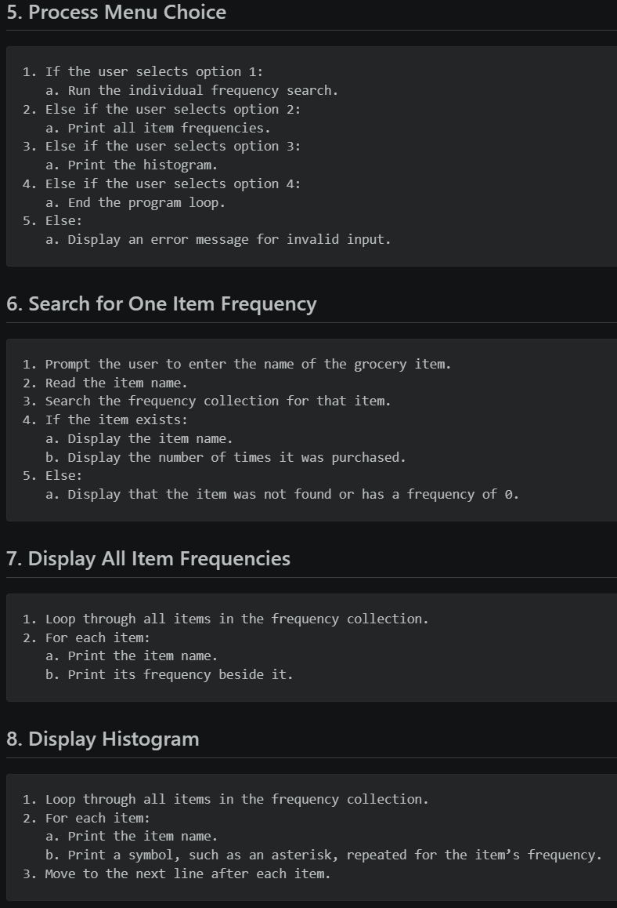

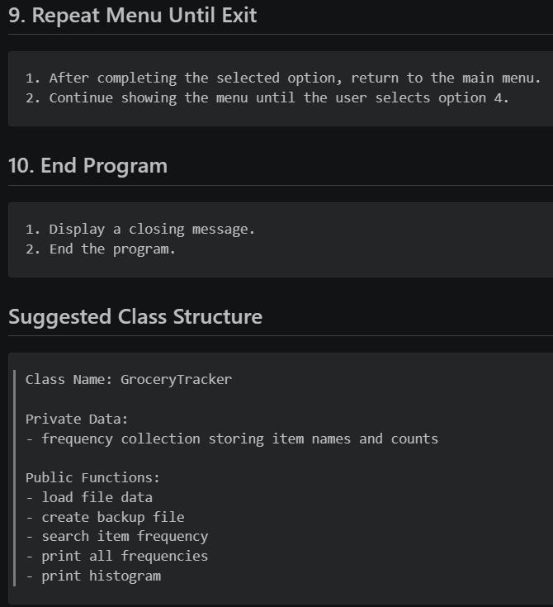

Core Algorithm Design
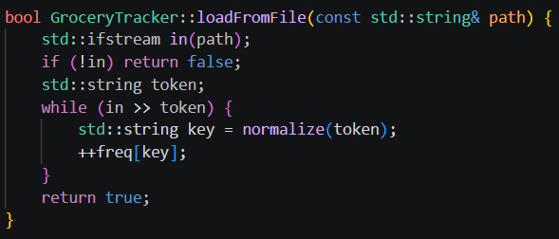
The program's most fundamental algorithm is the item frequency counting routine that runs during initialization. This algorithm must read every token from the input file, normalize it to lowercase, and either increment an existing map entry or insert a new one with a count of 1.

The search algorithm for Option 1 is a direct map lookup with normalization applied to the user's input before comparison, ensuring that "Potatoes," "potatoes," and "POTATOES" all match the same stored key.
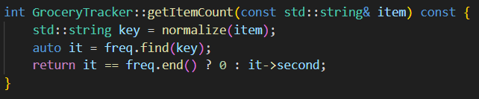

Data Structure Decisions (Why Map?)
The assignment recommends std::map, and that recommendation holds up under scrutiny. Here is why this solution uses it:
Data Structure | Strengths | Weaknesses for This Problem
std::map | O(log n) lookup; sorted iteration by key; direct key-value access; no duplicate keys by design | Slightly slower insertion vs. unordered_map
std::unordered_map | O(1) average lookup; faster insertion | No guaranteed iteration order; sorted output requires additional sort step
Parallel arrays | Simple to understand | O(n) lookup; no built-in duplicate prevention; harder to maintain
std::vector of pairs | Flexible storage | O(n) search unless sorted; requires manual frequency management
std::map was chosen for this project because the assignment requires printing items in a frequency list and histogram, and alphabetical ordering adds clarity and consistency to that output at no implementation cost. The map's find() method handles Option 1 lookup in O(log n) time. The map's guarantee of unique keys ensures each item is counted once without manual deduplication logic. For a dataset the size of a single day's grocery purchases, the performance difference between map and unordered_map is negligible.

Problem-Solving Strategy & Thought Process
Nothing was written all at once. The project was planned top-down and built bottom-up. Data infrastructure first, then the menu shell, then each option in order. At every stage the program compiled and ran.

- I defined the data contract. The GroceryTracker class interface was designed before any implementation. Deciding what the class exposes publicly and what it protects privately establishes the boundary between data management and display logic.

- I designed the repository layout. Knowing in advance how files would be organized prevented the common beginner mistake of placing all code in main.cpp. Each menu option was treated as a separate concern from the beginning.

- I designed the pseudocode for every algorithm. The pseudocode document provided a common use language blueprint that could be reviewed before any C++ was written, reducing implementation uncertainty.

- I drafted an annotation guideline to ensure that documentation remained clean, consistent, and scalable. Rather than relying on scattered inline comments, a structured documentation approach was defined using Doxygen style annotations within header files. This allowed detailed explanations to exist outside of the main logic, preventing code clutter while maintaining accessibility.

- I built from infrastructure to features. The data loading and backup logic was implemented first because all other features depend on it. The menu system was implemented second because it provides the user with an interface to interact with the data, this allowed me to build with intention and hold key checkpoints.

- Testing was conducted incrementally throughout development rather than postponed until completion. Step 5 and six were done by file instead of Infrastructure first then testing. So for each subfile and its partner .h file, I created custom test files to simulate different input scenarios, allowing validation of both expected behavior and edge cases.

- I added enhancements only after core requirements were met. Input validation, fuzzy search suggestion, and spacing utilities were written only after all four menu options were confirmed functional.

System Architecture & Repository Design

Project Structure Overview
This repository is more deliberately structured than a typical introductory C++ submission. Every folder has a single purpose; every file belongs to exactly one responsibility area. A grader, a collaborator, or the original author returning six months later should be able to locate any piece of logic without hunting.
The top-level entry point is main.cpp, which serves as the program's control center. From there, the project branches into five primary areas: data management, class declarations, menu implementation stages, design documentation, and test infrastructure.

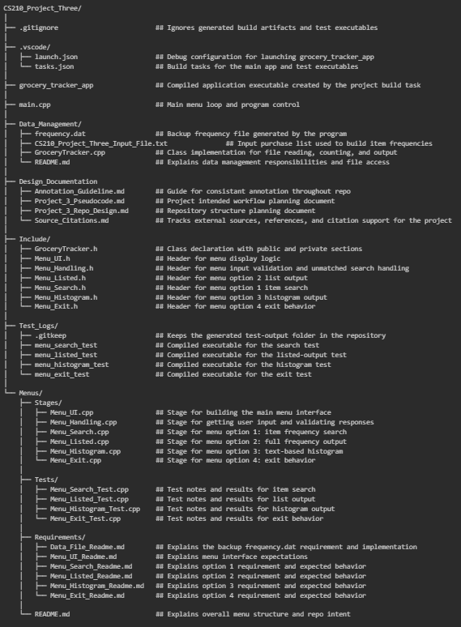
Folder & File Breakdown

Modular Design Philosophy
Giving each menu option its own header and source file is an application of the single responsibility principle. Each file has one job. The payoff is practical:

- Navigation: A grader reviewing Option 2 can open Menu_Listed.cpp and immediately see the entire implementation for that option without scrolling through thousands of lines.
- Isolation: A bug in the histogram implementation cannot accidentally affect the search implementation because they share no code and exist in separate translation units.
- Extensibility: Adding a new menu option in the future requires creating a new header, a new source file, and a single new case in the switch statement in main.cpp.
- Testability: Each stage can be compiled and tested independently using the test files in Menus/Tests/ before being integrated into the full application.
- Readability: By designing with intentional .h file usage, documentation is centralized using Doxygen style annotations rather than scattered inline comments. This allows the implementation files (.cpp) to remain clean and focused on logic, while detailed explanations are accessible through IDE features such as hover tooltips. The result is code that is both easy to read at a glance and well-documented when deeper understanding is needed.

Staged Development Approach
The Menus/Stages/ folder name is intentional. It signals that the menu features were developed incrementally, stage by stage, rather than all at once. This mirrors a professional agile development workflow where features are added to a working baseline incrementally.
The build order for this project was: data infrastructure first (GroceryTracker.cpp), then menu shell (Menu_UI.cpp), then input handling (Menu_Handling.cpp), then each menu option in order (Search, Listed, Histogram, Exit). At each stage, the program was compliable and runnable, even if not all features were complete.

Separation of Concerns: Logic vs. Interface vs. Data
This project cleanly separates its three main concerns across distinct physical layers of the codebase:
Concern | Location | Responsibility
Data Management | Data_Management/GroceryTracker.cpp | File I/O, frequency counting, map storage, backup writing
Class Interface | Include/GroceryTracker.h | Public API declaration, private member protection
User Interface | Menus/Stages/*.cpp | Menu display, user input, output formatting
Program Control | main.cpp | Menu loop, option routing, initialization orchestration
Shared Utilities | Include/Menu_Handling.h | Input validation, spacing utility, fuzzy search

This separation ensures that changing how data is stored does not require changes to the menu display files, and vice versa. The GroceryTracker class acts as the contract between the data layer and the interface layer, exposing exactly what the menus need while hiding all internal implementation details.

Functional Implementation Breakdown

Program Initialization & Data Loading
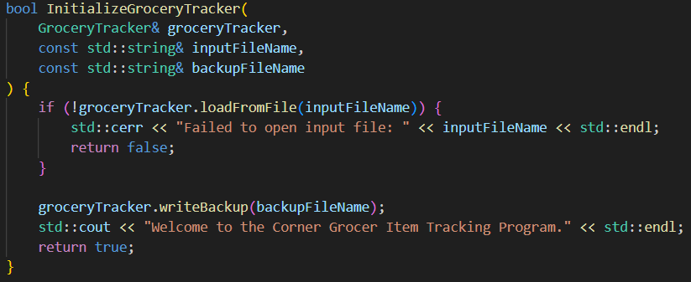
InitializeGroceryTracker() is a free function declared in GroceryTracker.h and implemented in Data_Management/GroceryTracker.cpp. main() calls it once at startup. It handles three things in order: loading the input file, writing the backup, and printing the welcome message.

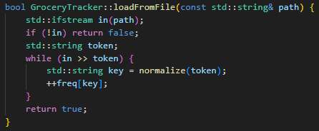
If the input file cannot be opened, the function returns false and main() exits with a non-zero return code, which is the conventional C++ signal for a program that terminated due to an error. The backup file is created automatically without user interaction, satisfying the assignment's data file creation requirement.
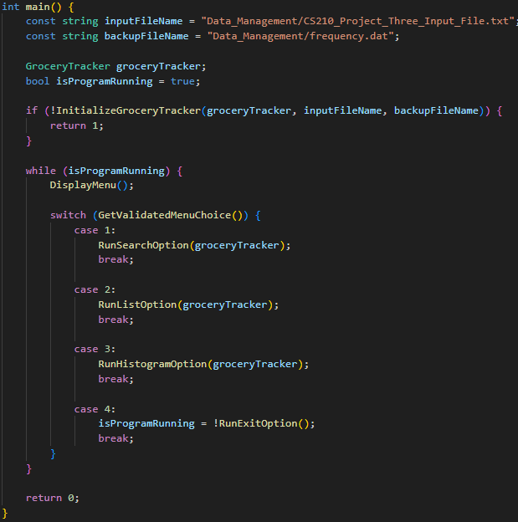
The loadFromFile() method reads items one token at a time using the stream extraction operator (>>), which automatically handles whitespace between items. Each token is normalized to lowercase before being stored as a map key, ensuring that case-insensitive lookup works correctly across all menu options.

Menu System & User Interaction
The main menu loop in main.cpp is a clean while loop that continues until the user selects Option 4. The menu display is handled by DisplayMenu() in Menu_UI.cpp, and input validation is handled by GetValidatedMenuChoice() in Menu_Handling.cpp. These two functions are intentionally separate because menu display and input validation are different concerns.

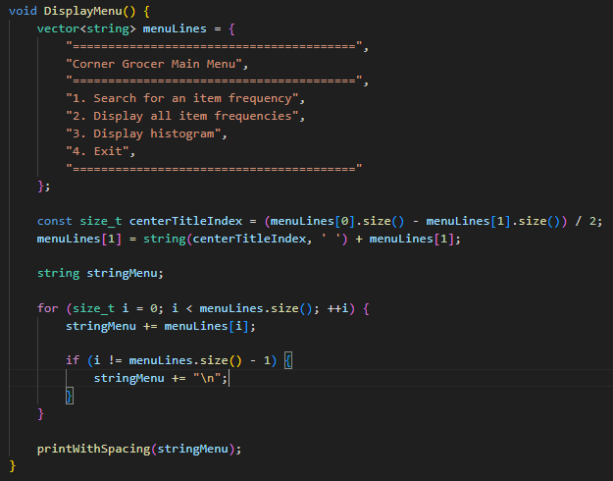
The DisplayMenu() function builds its output as a vector of strings and then performs a single-pass center-alignment calculation on the title line before printing. This avoids hardcoding spaces and ensures that if the menu width changes, the title realigns automatically.

Menu Option 1: Individual Frequency Search

Required Functionality
Option 1 prompts the user to enter a grocery item name and returns the number of times that item appears in the input file. The rubric requires a numeric value to be returned. This implementation returns that numeric value and also labels it clearly for the user.
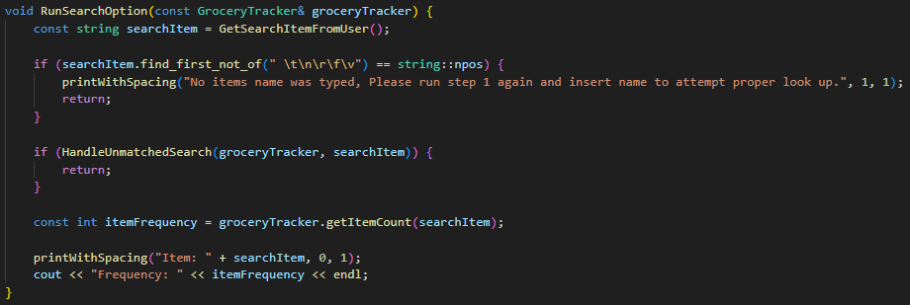

Supporting Logic
The search flow begins with GetSearchItemFromUser(), a self scoped helper function inside Menu_Search.cpp that prompts for and returns the user's input. Using getline() instead of >> ensures that items with spaces in their names can be captured correctly, though the current input file uses single word items.

Enhancements
Two enhancements go beyond the rubric here. The whitespace only input guard prevents a silent zero result when the user submits nothing. The unmatched search handler runs CountMatchingCharacters() against every item in the map and surfaces the closest match when a lookup fails. Both are tagged with @attention Additional Feature in the header so a reviewer can immediately identify what is required versus what is extra.

Menu Option 2: Overall Frequency List
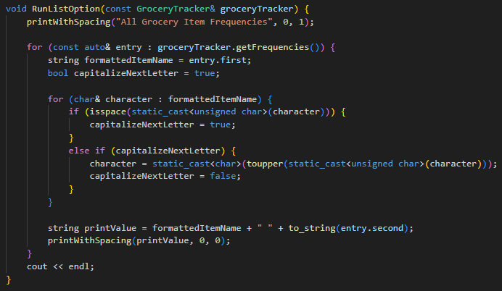
Option 2 iterates through the entire frequency map and prints every item name paired with its purchase count. Because std::map stores keys in sorted order, the output list is automatically alphabetical.
Items are stored internally as lowercase strings for case-insensitive lookup, but displayed in title case for readability. The title-case conversion loop applies toupper() to the first letter of each word. The static_cast<unsigned char> casts are required by the C++ standard to avoid undefined behavior when passing char values to character classification functions.

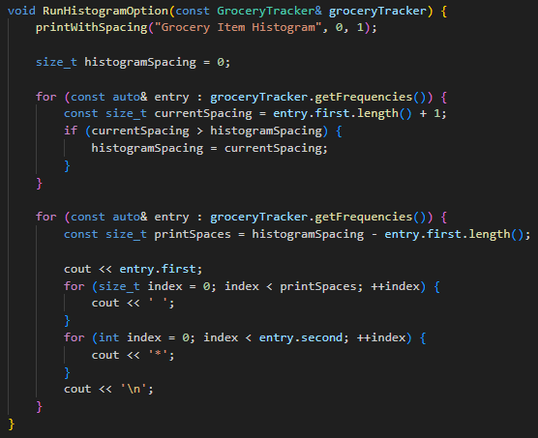
Menu Option 3: Histogram Visualization
Option 3 produces a text-based histogram where each item is printed with a number of asterisks equal to its purchase frequency. This implementation adds an alignment pass before printing to ensure that all asterisk bars begin at the same horizontal position regardless of item name length.

The two-pass approach avoids the simpler but visually inconsistent single-tab separator. When item names have varying lengths, a single tab produces a histogram where bars start at different horizontal positions. The alignment calculation ensures a professional-looking output where every bar begins at the same column.
Using size_t for length comparisons is deliberate. String length methods return size_t (an unsigned type), and comparing signed and unsigned values in C++ generates compiler warnings. Using size_t consistently avoids those warnings without requiring explicit casts.

Menu Option 4: Exit Mechanism
Option 4 is intentionally simple. RunExitOption() prints a closing message and returns true, which main() uses to set isProgramRunning to false and exit the while loop cleanly.
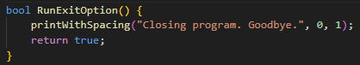

Returning a boolean from RunExitOption() rather than calling exit() directly is a deliberate design choice. It allows main() to remain in control of program termination and avoids the use of global program state. The while loop's condition check (isProgramRunning = !RunExitOption()) is handled naturally by the switch statement without requiring a break or special flag manipulation inside the exit function itself.

Function Scope & Classification

Required Functions (Rubric-Aligned)
Each of these functions maps to a specific rubric requirement. No function in this group is present for architectural convenience, each one exists because the assignment demands it:
Function | Location | Rubric Requirement Fulfilled
RunSearchOption() | Menus/Stages/Menu_Search.cpp | Menu Option 1: individual item frequency lookup
RunListOption() | Menus/Stages/Menu_Listed.cpp | Menu Option 2: complete frequency list output
RunHistogramOption() | Menus/Stages/Menu_Histogram.cpp | Menu Option 3: text-based histogram output
RunExitOption() | Menus/Stages/Menu_Exit.cpp | Menu Option 4: program exit with closing message
GroceryTracker::loadFromFile() | Data_Management/GroceryTracker.cpp | Data file input processing
GroceryTracker::writeBackup() | Data_Management/GroceryTracker.cpp | frequency.dat backup file creation
GroceryTracker::getItemCount() | Data_Management/GroceryTracker.cpp | Item-level frequency lookup for Option 1
GroceryTracker::getFrequencies() | Data_Management/GroceryTracker.cpp | Full-map access for Options 2 and 3

Supporting Architectural Functions
These functions are not explicitly named by the rubric but are essential to the program's architecture. They reduce code duplication and maintain the separation of concerns between layers:
Function | Location | Architectural Role
InitializeGroceryTracker() | Data_Management/GroceryTracker.cpp | Orchestrates startup: file load, backup write, welcome message
DisplayMenu() | Menus/Stages/Menu_UI.cpp | Renders the main menu with center-aligned title
GetValidatedMenuChoice() | Menus/Stages/Menu_Handling.cpp | Reads and validates menu input (1-4 only, integers only)
GroceryTracker::normalize() | Data_Management/GroceryTracker.cpp | Converts item names to lowercase for consistent lookup
printWithSpacing() | Menus/Stages/Menu_Handling.cpp | Shared output utility with configurable blank-line padding
GetSearchItemFromUser() | Menus/Stages/Menu_Search.cpp | Self-scoped helper that reads item name from user

Enhancement & Portfolio Level Features
These functions go beyond the rubric requirements. They are labeled with the @attention Additional Feature tag in their Doxygen annotations to make their non-required status immediately visible to a reviewer:

Function | Location | Enhancement Value
HandleUnmatchedSearch() | Menus/Stages/Menu_Handling.cpp | Detects missing search items and triggers closest-match suggestion
FindClosestMatchingItem() | Menus/Stages/Menu_Handling.cpp | Iterates map to find item with highest character overlap to user input
CountMatchingCharacters() | Menus/Stages/Menu_Handling.cpp | Counts shared characters between two strings for fuzzy matching

Design Justification for Additional Features
The fuzzy search suggestion feature was added because a blank result with no guidance is a poor user experience. If a user searches for "cranberry" instead of "cranberries," the program returns frequency 0 without any context. The unmatched search handler improves this experience by printing frequency 0 (meeting the rubric requirement for handling missing items) and then suggesting the closest match found in the grocery list.

The printWithSpacing() utility was added to avoid scattered bare endl calls throughout the codebase. Consistent output spacing is part of code maintainability. By centralizing spacing logic in one function with default parameters, every file that needs to print content with padding can do so with a single expressive function call.

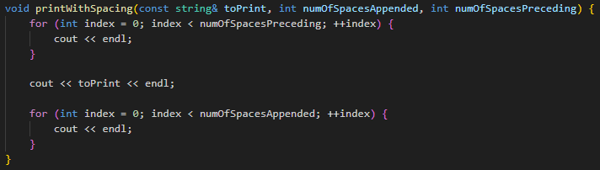

The empty input guard in RunSearchOption() was added because submitting an empty string to getItemCount() would silently return 0, which could be misinterpreted as a valid result. Detecting and rejecting empty or whitespace-only input is a standard input validation practice.

Data Management & File Handling

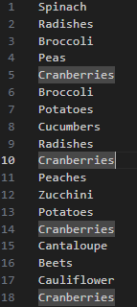
Input File Processing
The input file CS210_Project_Three_Input_File.txt contains one grocery item name per line, representing every purchase made at the Corner Grocer from store opening to close. A sample of the file content demonstrates its structure:
The file contains 20 distinct item types across a total of 98 purchase records. Items such as Cranberries (10 appearances) and Zucchini (10 appearances) are the most frequently purchased items in the dataset, while Limes (1) and Pears (1) are the least frequent.
The loadFromFile() method uses the stream extraction operator (>>) in a while loop, which reads one whitespace delimited token at a time. This handles both single word items and any potential multi line formatting in the file without requiring line by line processing. Each token is passed through the normalize() method before being stored as a map key.

Frequency Mapping Logic
The core data structure is a private member variable of type std::map<std::string, int> named freq. This map stores item names as keys and purchase counts as values. The C++ map operator[] behavior is exploited during counting: if the key does not exist, operator[] default-initializes the value to 0 before the increment applies. This means the counting loop requires no conditional logic:
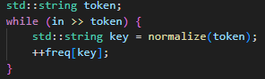

The normalize() function uses std::transform with a lambda that calls std::tolower on each character, wrapped in an unsigned char cast to satisfy the C++ standard's requirement for character classification functions. This ensures the function handles any character value without triggering undefined behavior.

Backup File Creation (frequency.dat)
The writeBackup() method creates the required frequency.dat backup file. This file is generated automatically during initialization, before the menu loop begins, satisfying the assignment requirement for backup file creation without user intervention.
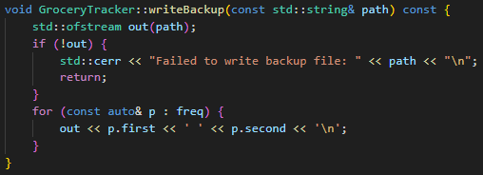

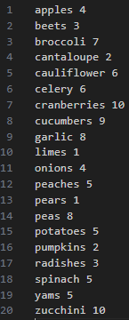
The resulting frequency.dat file for the provided input contains 20 entries, one per line, formatted as item_name count:

Items are written in alphabetical order because the map iterates its keys in sorted order. The file is stored in the Data_Management/ folder alongside the input file, keeping all data I/O assets in one place.

Data Integrity Considerations
A few decisions in the class design actively protect the frequency data from getting into a bad state:

- The freq map is private. No code outside of GroceryTracker can modify the frequency data after it has been loaded.

- getFrequencies() returns a const reference. Menu display functions receive read only access to the map and cannot accidentally alter any counts.

- getItemCount() applies normalize() to the user's input before lookup. This prevents case mismatches from producing incorrect zero results.

- File open failures are detected and reported to std::cerr before any map access is attempted. This prevents the program from operating on an empty or partial dataset without warning.

- The writeBackup() function checks that the output file opened successfully before writing. If the file cannot be created, an error is reported to std::cerr and the function returns without crashing.

Annotation & Documentation Strategy

Purpose of Code Annotation
Code annotation serves multiple audiences simultaneously. For the original developer, annotations provide a navigational reference during implementation. For future maintainers, they explain intent and design decisions that code alone cannot convey. For an academic grader, they demonstrate that the developer understands what the code is doing and why specific decisions were made.
The annotation in this codebase is calibrated, not so thin a reader has to guess intent, not so dense the comments crowd out the code. A written standard in Annotation_Guideline.md governs every decision, so the style holds across all files without having to be re-negotiated file by file.

Annotation Standards Used in This Project
The Annotation_Guideline.md document defines a stepped approach to annotation. Rather than applying a maximum detail template to every function, the guideline instructs the developer to start with the minimum useful annotation and add detail only when it genuinely improves clarity. The core rule is: if two annotations explain the code equally well, choose the shorter one.

Annotation Level | When to Use | Example Tag
Step 1: Minimal | Simple functions where name communicates purpose | @brief only
Step 2: Params + Returns | Functions with non-obvious inputs or outputs | @brief, @param, @return
Step 3: Success/Failure Notes | Functions with branching success or error paths | @brief, +/- outcome lines
Step 4: Additional Features | Functions outside core rubric requirements | @attention Additional Feature

Doxygen Style Documentation
This project uses a hybrid Doxygen style annotation format rather than full Doxygen tooling. The tags used are a subset of the Doxygen tag vocabulary: @brief, @param, @return, @note, @attention. These tags were chosen because VS Code's IntelliSense engine parses them and displays them in hover previews, providing documentation on hover without requiring any external documentation build step.
Full function documentation lives mostly in the header file, not the source file. When a developer hovers over any function call in the project, VS Code pulls the annotation directly from the header, no navigation required. The source file keeps only the decorative divider line and any implementation specific notes that would not belong in a public interface description.

Annotation Design Principle
The decorative function-name banner (// __________ FunctionName __________)
is kept as a plain // comment, separate from the Doxygen block. This is intentional: VS Code's hover preview only shows content from the /* */ block. The banner provides visual separation in the source file without appearing in the hover popup.

Header vs. Source Documentation Strategy
The documentation is split between header and source files using these rules, pulled directly from Annotation_Guideline.md:

- Header files (.h) contain the complete Doxygen annotation block for every declared function, class, and method. This is where @brief, @param, @return, @note, and @attention tags live.
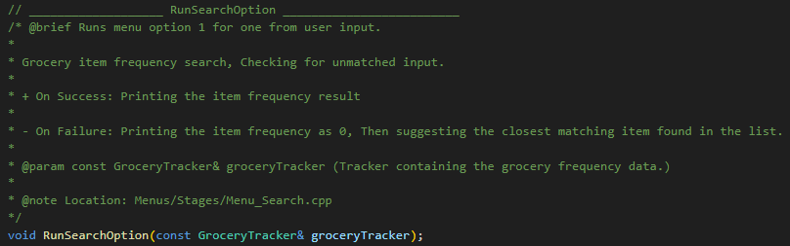

- Source files (.cpp) contain the file level header (identifying the file's purpose and its self-scoped vs. project-scoped exports), section dividers, and the decorative function name banner. Full Doxygen blocks are not repeated in .cpp files when a header already contains the annotation.
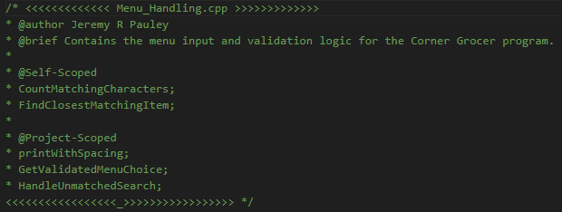

- The @note Location: tag is used in header annotations to show the relative path for the document containing the actual function.

- Self-scoped functions (private helpers defined and used within a single .cpp file) receive their full annotation in the .cpp file since they have no corresponding .h declaration.
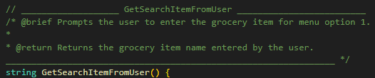

- The decorative function name banner is separated by a blank line deliberately from the item so that it does not compete with header file declarations. 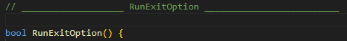

VS Code Integration & Developer Experience
The .vscode/ folder holds tasks.json and launch.json. Anyone who clones the repo and opens it in VS Code can build and debug immediately, no manual g++ invocation required.
The build task in tasks.json compiles all source files in a single g++ invocation, linking main.cpp, Data_Management/GroceryTracker.cpp, and all files in Menus/Stages/ into the grocery_tracker_app executable.
Separate build tasks compile each test file in Menus/Tests/ into independently runnable executables stored in Test_Logs/.

The result: hover over any function call to see its documentation; hit the default build task to compile the full app. No setup beyond cloning the repo.
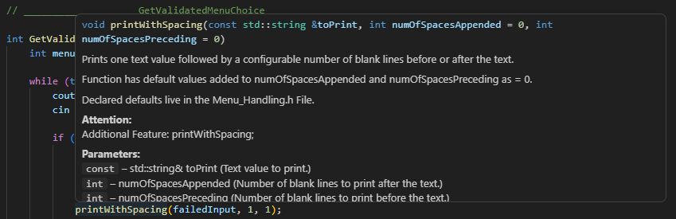

Industry Best Practices Applied

Naming Conventions
Naming follows a consistent set of rules across every file. The conventions align with modern C++ style, leaning on PascalCase for anything with external linkage and camelCase for locals and members:
Category | Convention | Examples
Classes | PascalCase | GroceryTracker
Free functions (project-scoped) | PascalCase | RunSearchOption, InitializeGroceryTracker, DisplayMenu
Free functions (self-scoped helpers) | PascalCase | GetSearchItemFromUser, CountMatchingCharacters
Member variables | camelCase | freq, closestMatch, searchCharacterCounts
Local variables | camelCase | menuChoice, itemFrequency, capitalizeNextLetter
Constants | camelCase (const local) | inputFileName, backupFileName
Parameters | camelCase | groceryTracker, searchItem, numOfSpacesAppended
Enumerations / none | N/A | No raw enums used; menu choices handled by switch
Folders / Directories | PascalCase with underscore (_) separation to distinguish from classes and functions | Data_Management, Menu, Stages, Test_Files
One intentional deviation from strict convention is that printWithSpacing() uses camelCase for a project-scoped function. This was chosen to visually distinguish it from the primary menu option functions (RunSearchOption, etc.) and to signal that it is a utility function rather than a menu handler. This decision is consistent throughout all call sites.

Code Readability & Maintainability
Readability and long-term maintainability guided every stylistic decision in this codebase:
- const correctness: All function parameters that are not modified are declared const. All member functions that do not modify state are declared const. getFrequencies() returns a const reference, protecting the map from external modification.
- Explicit casts: All casts to and from unsigned char are written explicitly with static_cast<> rather than C-style casts. This makes type conversions visible and reviewable.
- No magic numbers: The menu choice range (1 to 4) is expressed directly in the validation condition. The asterisk count for the histogram is driven entirely by the map value, with no hardcoded limits.
- Range-based for loops: All iteration over the frequency map uses const auto& range-based for loops, which are the idiomatic modern C++ approach and produce clearer code than iterator-based loops.
- Consistent file headers: Every source and header file begins with a file-level comment block identifying the file name, author, purpose, and scope exports, making it possible to understand a file's role by reading the first ten lines.

Input Validation & Error Handling
Validation runs at three separate points, each catching a different failure mode:
Point 1: Menu Choice Validation
GetValidatedMenuChoice() uses cin.fail() to detect non-integer input, clears the error state with cin.clear(), flushes the input buffer with cin.ignore(), and prompts again. Integer inputs outside 1-4 are also rejected with a clear error message.
Point 2: Empty Search Input Guard
RunSearchOption() checks whether the string returned by GetSearchItemFromUser() contains any non whitespace characters using find_first_not_of(). If the check fails, a message is printed and the function returns without attempting a lookup.
Point 3: File Open Failure Handling
Both loadFromFile() and writeBackup() check their file stream objects before attempting I/O. If the file cannot be opened, an appropriate error is sent to std::cerr and the function exits cleanly without accessing invalid state.
Together these three guards mean the program will not crash from bad user input and will not silently produce wrong output from a missing file.

Modular Development Practices
Modularity in this project goes down to the function level. No function is responsible for more than one logical task. When a function starts doing two things, one of those tasks gets extracted into a named helper.

The separation of GetSearchItemFromUser() from RunSearchOption() is a clear example. The rubric could be satisfied by reading input inline inside RunSearchOption(). Instead, the input prompt logic is extracted into its own self-scoped helper. This makes the top level RunSearchOption() function easy to read as a sequence of logical steps rather than a mix of input and logic.

The title case formatting in RunListOption() could have been extracted into a utility. It wasn't, because it appears in exactly one place and a named function would add a layer of indirection without clarifying anything. The annotation guideline puts it plainly: modularity should serve readability, not enforce it mechanically.

Program Output & Demonstration
The output below reflects the exact behavior of the compiled application running against CS210_Project_Three_Input_File.txt. Insert terminal screenshots at each subsection before final submission.

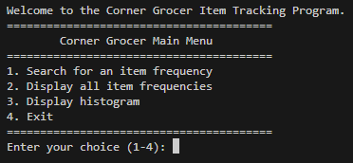
Menu Interface
On a clean startup, the welcome message prints and the menu loop begins. The title center-aligns dynamically based on the border width:

Individual Search Example (Option 1)
Searching for "cranberries" — in any casing — normalizes to the same map key and returns the stored count:
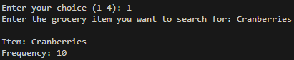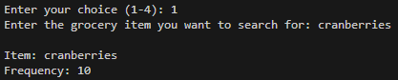

A failed lookup prints frequency 0 and surfaces the closest match:
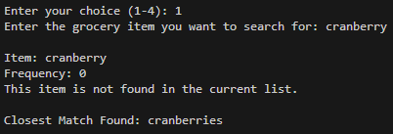
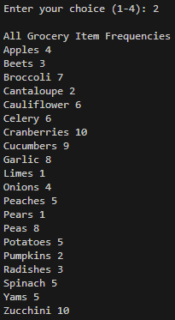

Full Frequency Output (Option 2)
Option 2 prints the complete list of all 20 items with their purchase counts, formatted in title case and sorted alphabetically:

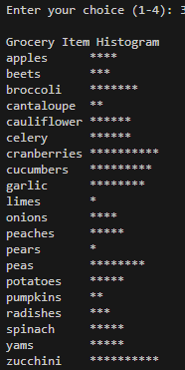

Histogram Output (Option 3)
Option 3 produces the aligned histogram. Because "cauliflower" is the longest item name at 11 characters, all asterisk bars begin at column 13 (name length + 2 spaces)

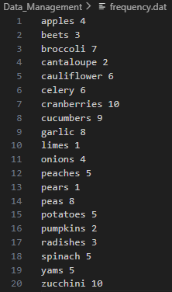

Backup File (frequency.dat)
frequency.dat is written at startup, before any user interaction. Its contents match the frequency list output but in lowercase, since items are stored in normalized form internally. The file lives at Data_Management/frequency.dat alongside the input file.

Reflection & Future Improvements

What Worked Well
Starting from the repository layout rather than from the code paid off throughout the project. Defining the folder structure, naming conventions, and annotation standards before writing any C++ meant every implementation decision had a clear place to land. There was no point where a new file had an ambiguous home.
The choice of std::map as the core data structure performed exactly as expected. The built-in sorted iteration made Options 2 and 3 output consistently alphabetical without any additional sort logic. The map's unique key guarantee eliminated the need for duplicate detection code. The logarithmic lookup time was more than adequate for a dataset of this size.
The Doxygen style annotation with the header file primary strategy proved highly effective in VS Code. Hovering over any project-scoped function call anywhere in the codebase immediately surfaces the complete annotation from the header file. This is exactly the behavior a developer would want from a production codebase.
The input validation implementation, particularly the GetValidatedMenuChoice() function's use of cin.fail() and cin.clear(), handled all tested invalid inputs correctly including strings, floats, negative numbers, and integers outside the 1-4 range. The empty-input guard in RunSearchOption() prevented a category of silent failure that would have been difficult to debug.

Challenges & Problem-Solving
The histogram alignment took the most iteration. Using a single \t between the item name and asterisks produces misaligned bars because tabs advance to fixed stops, not proportional offsets. The two pass approach, first finding the longest name, then computing per item padding, produces a consistent column that holds regardless of what items are in the dataset.
The char signedness issue in character classification functions (isspace, toupper, tolower) required careful handling. The C++ standard specifies that these functions have undefined behavior for negative char values, which can occur on platforms where char is signed and the character value exceeds 127. All character classification calls in this project use static_cast<unsigned char> to prevent this. Resolving this correctly required consulting the cppreference documentation for these functions. (cppreference.com, n.d.)
Managing the include path relationships between the Include/ folder and the Menus/Stages/ folder required relative path adjustments in the #include directives (../../Include/). While functional, this approach has a limitation: if the folder structure changes, all relative paths must be updated. A production project would solve this with compiler include path flags (-I flags in g++).

Potential Enhancements
A few directions worth pursuing if this project were to grow beyond the assignment scope:

- Persistent session logging: The program currently reads the input file once and processes all data at startup. A more robust version could monitor the input file for changes and update the frequency map dynamically throughout the business day.
- Case-preserved display with case-insensitive storage: The current implementation normalizes all items to lowercase for storage and applies title-case formatting during display. A more precise approach would store the original capitalization and apply normalization only during lookup, preserving the exact spellings from the input file in all outputs.
- Sort options for output: Options 2 and 3 currently produce alphabetical output because std::map sorts keys automatically. Adding a display mode that sorts by frequency descending would provide more actionable insights for store layout decisions (most popular items first).
- GUI or web interface: The text-based menu system is functional but limited. A future version could expose the GroceryTracker class through a REST API or connect it to a simple graphical interface, making the data more accessible to non-technical store managers.
- Multi-file input support: The current program reads a single input file. Supporting multiple files (one per day, for example) and aggregating their frequencies would enable weekly or monthly trend analysis.
- Unit test framework integration: The current test files in Menus/Tests/ are manual verification tools. Integrating a framework such as Google Test or Catch2 would allow automated regression testing and would make the test results reproducible and portable.

Real-World Application Potential
The Corner Grocer program addresses a genuinely common business analytics need: transforming raw transaction logs into actionable frequency data. The same core pattern — reading a log file, counting occurrences, presenting results in multiple views — shows up in production systems from web server log analyzers to retail inventory tools.
GroceryTracker's public API is clean, its internal state is protected, file I/O is error-checked, and every method that doesn't mutate state is marked const. For a dataset the size of one day's purchases it would hold up in production. The real limits are persistence — data disappears when the process exits — and raw scale, where a map over millions of items would need a different structure.
The skills demonstrated here 2014 designing a clean class interface, managing file streams safely, structuring a multi-file project, and writing self-documenting code 2014 translate directly to production C++ work. The gap between this implementation and a shipping product is persistence and scale, not architecture.

References & Project Summary

Source Citations
APA citation for the input data provided by SNHU:

Southern New Hampshire University. (n.d.). CS210_Project_Three_Input_File.txt. Brightspace. https://learn.snhu.edu/content/enforced/2200145-CS-210-15479.202616-1/course_documents/CS210_Project_Three_Input_File.txt

cppreference.com. (n.d.). Fundamental types. Retrieved April 10, 2026, from https://en.cppreference.com/w/cpp/language/types.html

Files Required for Compilation
To compile the full application from the command line:

g++ -std=c++17 -Wall -Wextra -o grocery_tracker_app \

main.cpp \

Data_Management/GroceryTracker.cpp \

Menus/Stages/Menu_UI.cpp \
Menus/Stages/Menu_Handling.cpp \
Menus/Stages/Menu_Search.cpp \
Menus/Stages/Menu_Listed.cpp \
Menus/Stages/Menu_Histogram.cpp \
Menus/Stages/Menu_Exit.cpp

Header files are included via relative paths in each source file, so they don't need to be listed in the compile command. CS210_Project_Three_Input_File.txt must exist at Data_Management/ relative to wherever the executable runs.

Complete Function Index
Every function in the project, its file, and its classification:

Function | File | Scope
main() | main.cpp | Entry Point
InitializeGroceryTracker() | Data_Management/GroceryTracker.cpp | Project-Scoped
GroceryTracker::GroceryTracker() | Data_Management/GroceryTracker.cpp | Class Member
GroceryTracker::loadFromFile() | Data_Management/GroceryTracker.cpp | Class Member
GroceryTracker::writeBackup() | Data_Management/GroceryTracker.cpp | Class Member
GroceryTracker::getItemCount() | Data_Management/GroceryTracker.cpp | Class Member
GroceryTracker::getFrequencies() | Data_Management/GroceryTracker.cpp | Class Member
GroceryTracker::normalize() | Data_Management/GroceryTracker.cpp | Private Member
to_lower_copy() | Data_Management/GroceryTracker.cpp | Self-Scoped
DisplayMenu() | Menus/Stages/Menu_UI.cpp | Project-Scoped
GetValidatedMenuChoice() | Menus/Stages/Menu_Handling.cpp | Project-Scoped
printWithSpacing() | Menus/Stages/Menu_Handling.cpp | Project-Scoped
HandleUnmatchedSearch() | Menus/Stages/Menu_Handling.cpp | Project-Scoped (Enhancement)
FindClosestMatchingItem() | Menus/Stages/Menu_Handling.cpp | Self-Scoped (Enhancement)
CountMatchingCharacters() | Menus/Stages/Menu_Handling.cpp | Self-Scoped (Enhancement)
RunSearchOption() | Menus/Stages/Menu_Search.cpp | Project-Scoped
GetSearchItemFromUser() | Menus/Stages/Menu_Search.cpp | Self-Scoped
RunListOption() | Menus/Stages/Menu_Listed.cpp | Project-Scoped
RunHistogramOption() | Menus/Stages/Menu_Histogram.cpp | Project-Scoped
RunExitOption() | Menus/Stages/Menu_Exit.cpp | Project-Scoped

